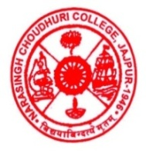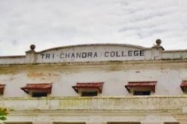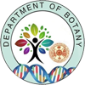
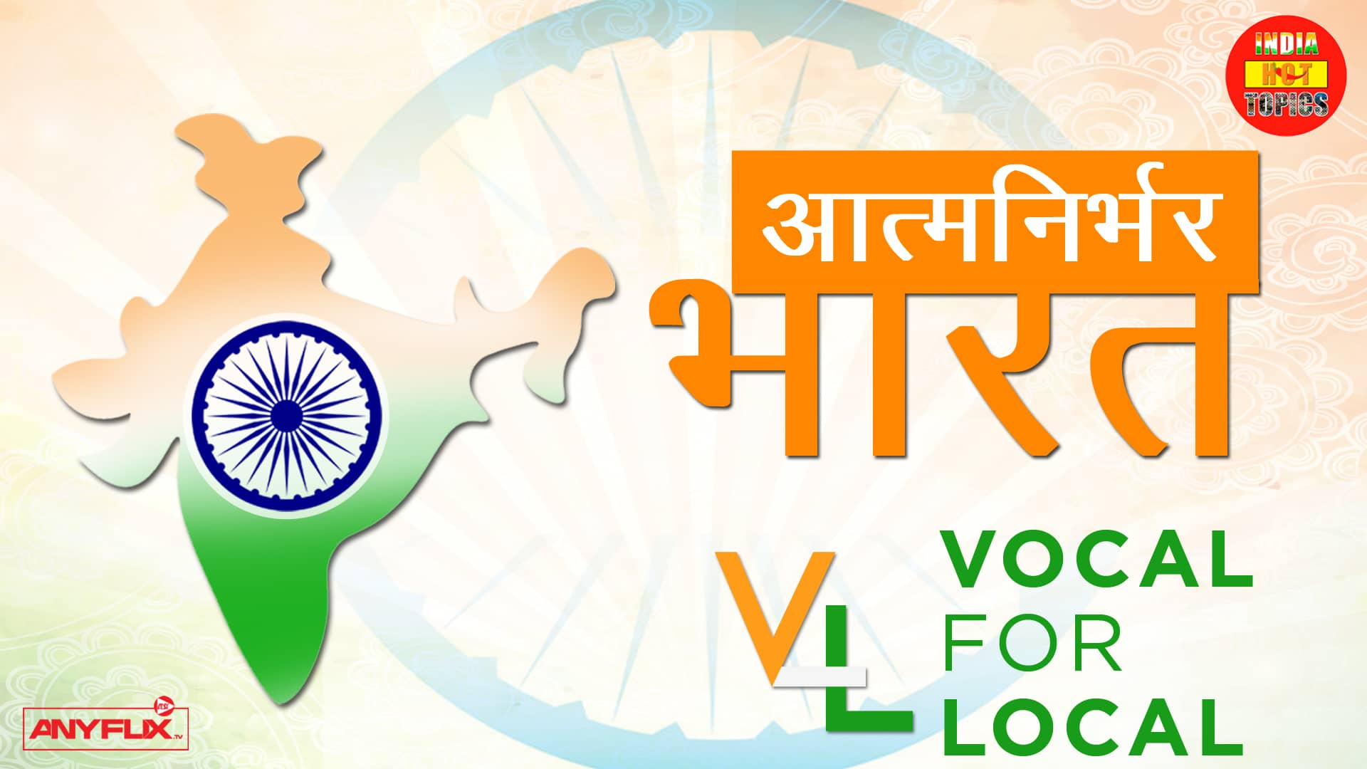 INTERNATIONAL VIRTUAL CONFERENCE ON “VERMICOMPOSTING AND ORGANIC FARMING”
(29TH & 30TH AUGUST 2020)
ORGANIZED BY
DEPARTMENT OF BOTANY
NARASINGH CHOUDHURY AUTONOMOUS COLLEGE, JAJPUR, ODISHA, INDIA (NAAC ACCREDITED)
IN ASSOCIATION WITH
DEPT. OF ENVIRONMENTAL SC, TRICHANDRA MULTIPLE CAMPUS, TRIBHUVAN UNIVERSITY, KATHMANDU, NEPAL
SUPPORTED BY
THE WORLD BANK
PROGRAMME SCHEDULE
DATE- 29.08.2020(SATURDAY)
Host- DR SARADA PRASAD MOHAPATRA, HEAD, DEPT OF BOTANY & ACADEMIC HEAD, N C AUTONOMOUS COLLEGE, JAJPUR
2.45 PM Presentation of activities of N. C (A) College, Jajpur, Odisha, India by Dr Kshan Prabha Sahoo, Lecturer, Dept of Botany & Joint Organizing Secretary, International Virtual conference
3.10 PM Welcome Address & Release of E Book” VERMICOMPOST TECHNOLOGY AND SUSTAINABLE FARMING” by Dr Biswajit Mohapatra, I/C, UGC, Asst Prof, Dept. of Botany, Narasingh Choudhury Autonomous College, Jajpur, Odisha, India, Convener, International Virtual conference
3.15 PM Address by Sri Bhaba Prakash Das, Chairman, Jajpur Municipality, Jajpur, Odisha(Hon’ble Guest)
3.20 PM Address by Prof. Manoj Kumar Mohapatra, Head, Dept of Zoology, N.C Autonomous College, Jajpur, Odisha(Chairperson)
3.25 PM Address by Mr Debraj Behera, Livelihood Specialist, International Consultant, World Bank (Chief Guest)
3.40 PM Address by Hemlal Bhattarai, Lecturer & Dean, Research and Industrial Linkages, Royal University of Bhutan, Jigme Namgyel Engineering College(Hon’ble Guest)
3. 50 PM Address by Dr. Sandeep Kumar Panda, School of Biotechnology, KIIT University, Bhubaneswar, Odisha (Hon’ble Guest)
4.00 PM Presentation by Kishor Maharjan, Head, Dept of Env Sc. Trichandra College, Tribhuvan University, Kathmandu, Nepal (Resource Person)
4.40 PM Question- Answer Session
5.00 PM Report by Chairperson
5.10 PM Appreciation address by Dr Kshan Prabha Sahoo, Joint Organizing Secretary, International Virtual conference
Date- 30.08.2020 (SUNDAY)
3.20 PM Welcome Address by Dr Kshan Prabha Sahoo, Joint Organizing Secretary, International Virtual conference
3.25 PM Address by Prof. F.M.Mallick, Principal, N.C Autonomous College, Jajpur(President)
3.30 PM Address by Dr Biswajit Mohapatra, I/C, UGC, Asst Prof, Dept. of Botany, Narasingh Choudhury Autonomous College, Jajpur, Odisha, India, (Chairperson)

3.40 PM Address by Juliet Dhanraj, Placement and Career Specialist/Field Programming Coordinator, Green Economy Bridging Program, Gateway for International Professionals, Ryerson University, Canada (Chief Guest)
3.50 PM Presentation by Dr. Mukul C Kalita, Principal Scientist, Livestock Station, Assam Agricultural University, Assam (Resource Person)
4.20 PM Address by Prof. Manoj Kumar Mohapatra, Head, Dept of Zoology, N.C Autonomous College, Jajpur, Odisha(Resource Person)
4.50 PM Presentation by Selected Participants
5.20 PM Question- Answer Session
5.30 PM Address by Praveen K Regmi, Dept of Env Sc, Trichandra College, Tribhuvan University, Kathmandu, Nepal (Hon’ble Guest)
5.35 PM Report by Chairperson
5.40 PM Appreciation address by Dr Kshan Prabha Sahoo, Joint Organizing Secretary, International Virtual conference
*******************

