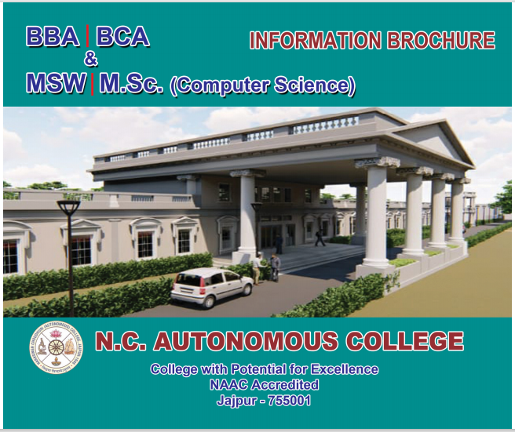
HISTORY OF THE COLLEGE

The College is named after Late Choudhary Narasingha Charan Mohapatra of Kodandapur, the Principal donor of the institution. Founded on June 18, 1945, the college fulfilled a long cherished desire of the people of this area. Classes were held in Jajpur High School till 1952 and thereafter the college was shifted to its present campus that stretches in a serene rural setting, about two kilometers to the west of the historical town of Jajpur.
The college was at first affiliated to Utkal University up to the intermediate level in the faculty of Arts, and subsequently it grew in to a degree in Arts, obtaining affiliation to the same University in 1961. Further affiliations followed in quick succession when the Government took over the management of the college on July 1, 1962. By the end of the 70, it had grown into a full-fledged degree college with honours courses in Arts and Science. The faculty of commerce started working in 1980.
The institution was elevated to a postgraduate college with postgraduate course in History in 1980. The postgraduate department of mathematics started its work in 1990.
The college has sound infrastructure as regards to classrooms, library, computer laboratory, auditorium, separate hostels and gym for boys & girls and playground.
The college marches ahead on the path of glory over the years. It was declared to be one of the lead colleges of the State by the Government in 1990. The college has been accorded autonomous status from the session 1999-2000 and re-accredited by the NAAC in 2011. UGC has selected N.C. Autonomous College under the scheme college with potential for Excellence during the 11th Plan Period vide Letter No. F-12-1/2008.
The Govt. has accorded permission to open BBA and BCA as bachloer degree self-financing courses from the session 2013-14. Later MSW and MSc (Computer Science) have been included as Master Degree Self-Financing courses.

Self Financing Course Programme

Objective.
- Keeping in view the demand of career oriented self financing courses in Jajpur, BBA, BCA, MSW and Msc in Computer Science have been introduced with following objectives.
- Quality teaching through highly experienced faculties of this college as well as from other institutions and Universities.
- Seminar & Group discussion shall be an integral part.
- High tech computer lab facilities for students.
- Soft skill development programme like facing interview, communication skill and public speaking skill shall taught by experts.
- Placement training for on/off campus.

Courses Offered
BACHELOR DEGREE COURSES
BBA (Bachelor in Business Administration) : 48 Seats
BCA (Bachelor in Computer Application : 192 Seats
Eligibility for Admission
The candidates seeking admission to this course must have possessed the following academic qualifications.
1. +2 Science/Arts / Commerce or equivalent degree accepted by the Principal, N.C (A) College, Jajpur.
MASTER DEGREE COURSES
MSc in Computer Science : 48 Seats
(Master in Computer Science)
ELIGIBILITY
Any graduate with Mathematics in +2

MSW (Master of Social Works) : 48 Seats
ELIGIBILITY
Any graduate with 45% Pass mark

If the results of the qualifying examination has not been published by the time of admission, a candidate may be admitted into BBA, BCA, MSW and MSc (Computer Science) course provisionally as per the merit list, provided that such candidates shall submit their pass result before they fill up forms for the first semester examination failing which their admission into BBA, BCA, MSW and MSc (Computer Science) shall be cancelled without refund of any fees taken at the time of admission.

Reservation and Weightage
The reservation and weightage policy for candidates belonging to SC, ST, PH, and Children of Ex-servicemen of the IAF, children of defense personnel, Sports or Games personnel categories shall be applicable as per the rules followed by the Government guide-lines.

MSc in Computer Science
Course Structure of MSc Under Semester System
Semester-I
Semester-III
- Artificial intelligence
- Software engineering
- Compiler design
- (a) Network security (or)
- (b) Cloud computing
- (a) Embedded system (or)
- (b) Mobile computing
- A1 Programming lab
- Software engineering lab

- Data structure and algorithms
- Computer system architecture
- Database systems & implementation
- Discrete mathematical structures
- Visual programming (or)
- Objective oriented design using UML
- Algorithims lab
- Database lab

Semester-II
Semester IV
- Comprehensive viva
- Project work and viva voce

- Computer networks
- Advanced JAVA
- Operating system design
- Theory of computation
- (a) Data mining (or)
- (b) Computer graphics
- JAVA programming lab
- Operating systems lab

MSW (Master in Social Work)
Course Structure of MSW Under Semester System
Semester - I
- Foundations of social work:
- History, philosophy & values of social work
- Social science concept - I: Social structure, social institutions and social change
- Social science concept - II: Introduction to Political Economy
- Social science concept - III : Psychology for Social work
- Working with individuals & Groups
- Orientation Programme & Observation visit:
- Method workshops
- Seminars Concurrent
- Field work

Semester-II
- Community work, Social action & social change
- Social mobilization, Social movement & Social transformation
- Social policy analysis
- Development approach in social work practice
- Gender in social work practice
- Concurrent field work + rural camp

MSW (Master in Social Work)
Semester III
- Social work research methods workshops
- i) Qualitative & Quantitative methodology
- ii) Writing workshop - Creative & Academic (Research Proposal)
- Social Work practice with SC, ST, OBC & Minorities
- Human Rights approach to social work practice
- Climate change & DRR approach to social works practice
- Agrarian social work
- Natural resource governance & sustainability
- Counseling skills in Social work Any one
- Social works with children & families
- Social work the elderly
- Concurrent filed work + Project work
Semester IV
- i) Social Welfare Management Workshops: Project Planning
- ii) Proposal writing
- Management of community based organisations workshops
- i) Social innovation & Marketing
- ii) Finance & Accounting
- Dissertation Research project
- Preventive & community Health
- Microfinance & Financial inclusion
- New media management for social workers
- Social Works practice in mental health
- Substance abuse prevention & rehabilitation of persons with addictions
- Concurrent filed work + Block placement

Semester - IV
Code Subject
401 Financial management
402 Marketing management
403 Human resource management
404 Production and operation management
405 Environmental studies
Semester - V
Code Subject
501 Organizational behavior
502 Financial markets and institutions
503 Advertisement and sales promotion
504 Management information system and DSS
505 Indian society and culture

Semester - VI
Code Subject
601 Research methodology
602 Entrepreneurship and small business management
603 Organizational change and development
604 Dissertation and viva-voce
605 E-business

BBA (Bachelor in Business Administration)
Course Structure of BBA Under Semester System
Semester-I
Code Subject
101 Introduction of business
102 English language and literature
103 Quantitative techniques for management
104 Basic financial accounting

Semester-II
Code Subject
201 Economics
202 Management accounting
203 Cost & management accounting
204 Computer for management (including practical)

Semester - III
Code Subject
301 Psychology for management
302 Business ethics and corporate governance
303 Introduction to banking and insurance
304 Business and corporate law
305 Communicative English

BCA (Bachelor in Computer Application)
Course Structure of BCA Under Semester System
Semester - II
AEC-2 : English
CC-3 : Programming using C++
CC-4 : Data Structure
GE/IC-2 : Statistics
CC-3 Practical : C++ LAB
CC-4 Practical : Data Structure LAB
GE/IC-2 Tutorial /Practical

Semester – IV
CC-8 : Operating System
CC-9 : Computer Networks
CC-10 : Database Systems
SEC-2 : Android Programming
GE/IC-4 : Business Economics
CC-8 Practical : OS LAB
CC-9 Practical : CN LAB
CC-10 Practical : Database LAB
GE/IC-4 Tutorial/Practical

Semester - I
AEC-1 : Environmental Science
CC-1 : Digital Logic
CC-2 : Programming using C
GE/IC-1 : Principles of Management
CC-1 Practical : DL LAB
CC-2 Practical : C LAB
GE/IC-1 Tutorial/Practical

Semester - III
CC-5 : Computer Organization
CC-6 : JAVA Programming
CC-7 : Discrete Mathematical Structures
SEC-1 : Python Programming
GE/IC-3 : Business Accounting
CC-5 Practical : CO LAB
CC-6 Practical : JAVA LAB
CC-7 Practical : DMS LAB
GE/IC-3 Tutorial/Practical

BCA (Bachelor in Computer Application)

Semester – V
CC-11 : Web Technology
CC-12 : Software Engineering
DSE-1 : Unix Programming
DSE-2 : Data Mining
CC-11 Practical : Web Technology LAB
CC-12 Practical : Software Engineering LAB
DSE-1 Practical/ Tutorial : Unix Programming LAB
DSE -2 Practical/ Tutorial : Data Mining LAB)

Semester – VI
CC-13 : Computer Graphics
CC-13 : Practical Computer Graphics LAB
CC-14 : Numerical Techniques
DSE-3 : Data Science
CC-14 Practical : Numerical Techniques LAB
DSE -3 Practical/ Tutorial : Data Science LAB
DSE-4 : Project Work

Course Fees
Course Fee of BBA & BCA

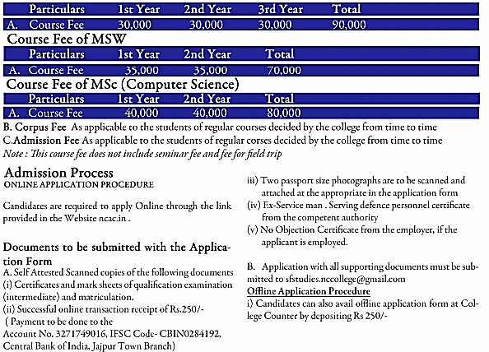

Selection Procedure
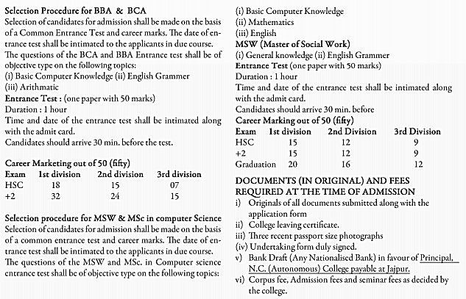

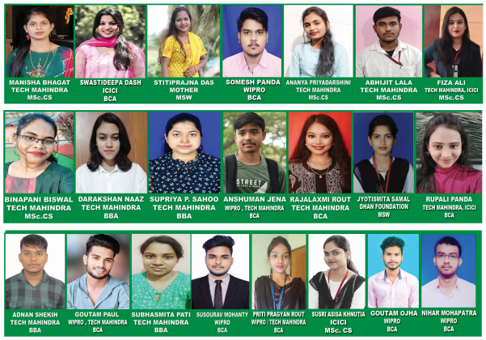
OUR ACHIEVERS

OUR GLORIES
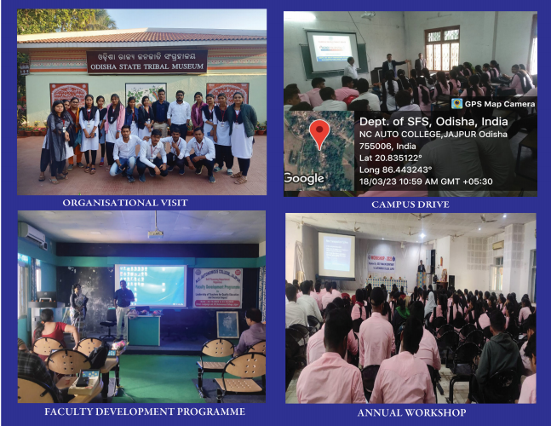

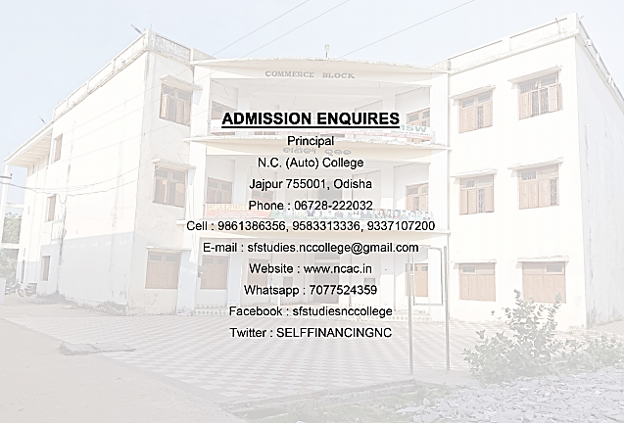
Contact Details
Contact Details

