DEPARMENT PROFILE

NAME OF THE DEPARTMENT: PHYSICS

MISSION:
To impart high quality state of the art academic programmmes in Physics and in interdisciplinary areas to create competency and skills with an emphasis on creation of intellectual property through innovations and quality research.

HISTORY OF THE DEPARTMENT:

The department of Physics came into existence in the year 1968 where it started teaching Physics honours courses. Since then, the department has been immensely involved in teaching prescribed Physics courses from time to time. It has so far contributed in creating large number of trained graduates who have been serving in various sectors that include academics, research and development, engineering and technology, banking and finance, management and administration. The faculties of the department have been greatly involved research activities and have published many research articles in high impact international and national journals.

COURSES OFFERED: B. Sc, M. Sc

YEAR OPENING OF HONOURS SUBJECT: 1968

YEAR OPENING OF PG SUBJECT: 2023

STUDENT STRENGTH UG:
SL.NO | COURSE | YEAR | SANCTIONED STRENGTH | STUDENTS ADMITTED
1 | B.Sc Hons | I | 48 | 44
2 | B. Sc Hons | II | 32 | 23
3 | B. Sc Hons | III | 32 | 24

STUDENT STRENGTH PG:
SL.NO | COURSE | YEAR | SANCTIONED STRENGTH | STUDENTS ADMITTED
1 | M.Sc | I | 24 | 22

UG
NAME OF THE PAPAER | MARKS |  | CREDIT POINTS
 | INTERNAL | SEMESTER
Mathematical Physics–I (CC-I) | 15 | I | 6
Mechanics (CC-II) | 15 | I | 6
Electricity and Magnetism (CC-III) | 15 | II | 6
Waves and Optics (CC-IV) | 15 | II | 6
Mathematical Physics – II (CC-V) | 15 | II | 6
Thermal Physics (CC-VI) | 15 | III | 6
Analog Systems and Applications (CC-VII) | 15 | III | 6
Mathematical Physics – III (CC-VIII) | 15 | IV | 6
Elements of Modern Physics (CC-IX) | 15 | IV | 6
Digital Systems and Applications (CC-X) | 15 | IV | 6
Quantum Mechanics and Applications (CC-XI) | 15 | V | 6
Solid State Physics (CC-XII) | 15 | V | 6
Classical Dynamics (DSE-I) | 20 | V | 6
Nuclear and Particle Physics (DSE-II) | 20 | V | 6
Electromagnetic Theory (CC-XIII) | 15 | VI | 6
Statistical Mechanics (CC-XIV) | 15 | VI | 6
Nano Materials and Applications (DSE-III) | 20 | VI | 6
Project (DSE-IV) | - | VI | 6

PG
NAME OF THE PAPAER | MARKS |  | CREDIT POINTS
 | INTERNAL | SEMESTER
PHY101: Classical Mechanics | 30 | I | 6
PHY102: Mathematical Methods in Physics | 30 | I | 6
PHY103: Quantum Mechanics-I | 30 | I | 6
PHY104: Modern Physics and Optics (Practical) | - | I | 6
PHY201:Quantum Mechanics –II | 30 | II | 6
PHY202: Classical Electrodynamics | 30 | II | 6
PHY203: Basic Condensed Matter Physics | 30 | II | 6
PHY204: Computational Methods in Physics | - | II | 6
PHY301: Advanced Quantum Mechanics | 30 | III | 6
PHY302: Electronics | 30 | III | 6
PHY303b: Advanced Condensed Matter Physics- I | 30 | III | 6
PHY304: Electronics (Practical) | - | III | 6
PHY305a: Dissertation/Project | - | III | 4
PHY305b: Review of Literature | - | III | 2
PHY401: Basic Nuclear and Particle Physics | 30 | IV | 6
PHY402: Statistical Mechanics | 30 | IV | 6
PHY403b: Advanced Condensed Matter Physics-II | 30 | IV | 6
PHY404b: Condensed Matter Physics (Practical) | - | IV | 6

INFRASTRUCTURE:

Well equipped Laboratories, Computer lab, Seminar, Smart class room,

ALUMNI/ACHIEVERS:

Sl. No | Name | Year of Pass Out | Achievement
32 | Dibeswar Behera | 2023 | Qualified JAM (AIR 331)

SEMINARS: Student seminars organized

STUDENTS’ PROGRESSION:

Name of Student | Batch | Progression to Higher studies
Ruchismita Mahalik | 2022 | M.Sc (Bhadrak Auto. College)
Swetashree Satapathy | 2022 | M.Sc. (F. M Auto. College)
Biswajit Mahalik | 2022 | M.Sc (Dhenkanal auto. Collge)
Somnath Ojha | 2022 | M.Sc. (U.N. Auto. College)
Dibeswar Behera | 2023 | M.Sc (IIT)
Sanjeeb K. Sahoo | 2023 | M.Sc (N.C. Auto.College)
Najmus Shakib | 2023 | M.Sc (North Odisha University)
Saphalya Rout | 2023 | B. Ed (RIE, Bhubaneswar)
Dipanjali Sahoo | 2023 | M.Sc (Bhadrak Auto. College)
Monalisha Behera | 2023 | M.Sc (North Odisha University)

STUDENTS’ PLACEMENT:
Karan Sahoo (2023 Passout batch): GDS

STUDENT GOT NET/SLET/GATE/ JRF ETC.: NO

FACULTY PROFILE:

Sl.No | Name | Qualification | Designation | Photo
1 | Dr. Guruprasad Sahoo | M. Sc, Ph.D | Assistant Professor | 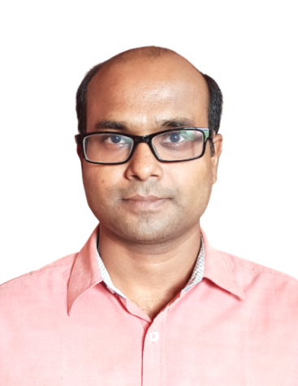
2 | Dr. Prachiprava Mohapatra | M. Sc, M.Phil, Ph.D | Assistant Professor | 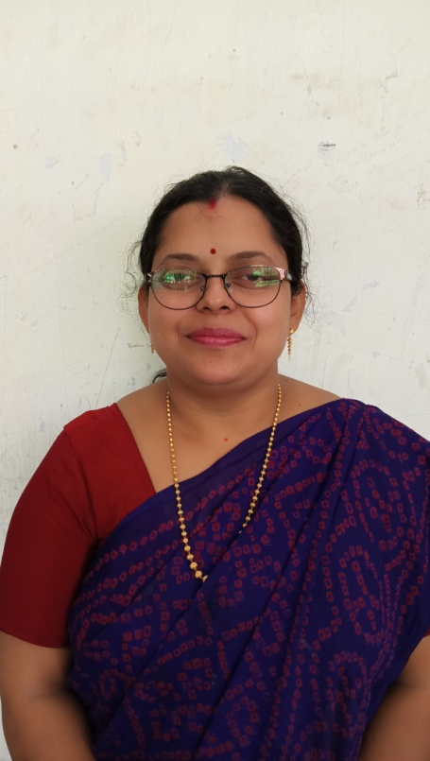
3 | Dr. Suresh Kumar Goi | M. Sc, M. Phil, Ph.D | Lecturer (SS) | 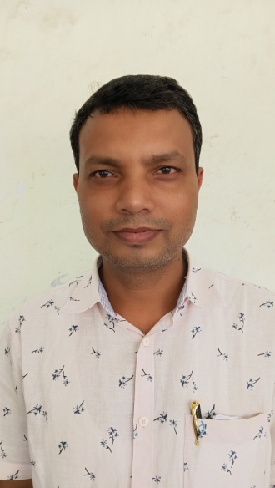
4 | Dr. Saswati Panda | M. Sc., Ph. D | Assistant Professor | 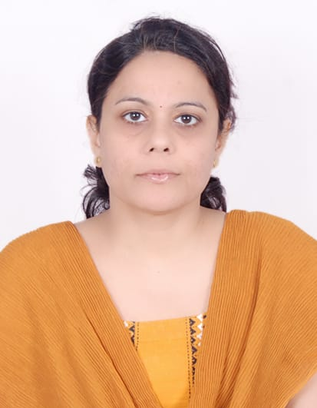
5 | Dr. Saparjya Samarpita | M. Sc., Ph. D | Assistant Professor | 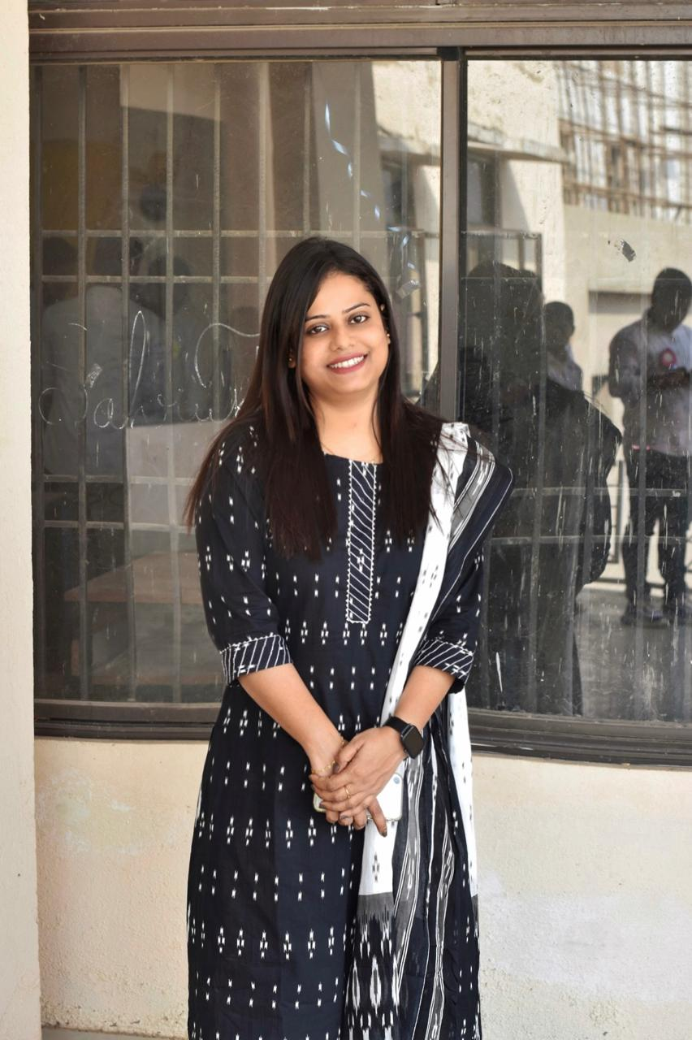
6 | Dr. Amruta Pritam Mishra | M.Sc, MBA, B.Ed,DSM, Ph.D | Lecturer | 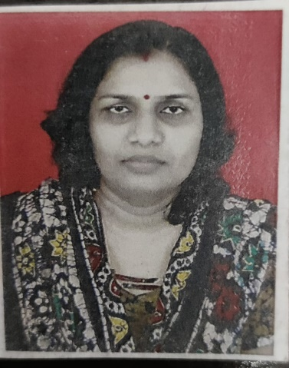
7 | Dr. Sumati Pati | M. Sc, B.Ed, Ph.D | Lecturer | 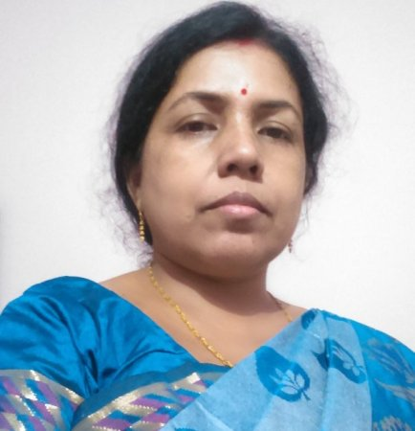

REMARKABLE ACHIEVEMENTS:
Ongoing Research Project (Budget amount Rs. 10 lakhs) sponsored by DST, Govt. of Odisha, Principal Investigator: Dr. Guruprasad Sahoo

PUBLICATIONS:
- Guruprasad Sahoo and Ajit Jena, Unraveling the strain and inherent onsite-correlation effect on the electronic structure of pure and iso-electronic Ag doped copper nitride, Materials Today Communications 33, 104194 (2022).
- Guruprasad Sahoo, Manipulating elastic and mechanical properties of Cu3N through site selective Ag doping: First principles investigation, Materials Today Communications 29, 102950 (2021).
- Guruprasad Sahoo, Site selective Ag doping in Cu3N and its consequences on structural and electronic properties: A DFT study, Physica B: Physics of Condensed Matter 619, 413238 (2021).
- S. Devi, S. Saparjya, S. Behera, Crystal structure, dielectric and impedance studies of a new lead-free tungsten-bronze ferroelectric oxide, Ferroelectrics 587 (2022) pp. 104-117. DOI: 10.1080/00150193.2022.2034420. (Pub: Taylor Francis, Indexed in: SCI, SCOPUS).
- Saparjya, S., Behera, S., Badapanda, T., Behera, B., Padhee, R., & Das, P. R. (2022). Understanding the impact of Gd3+ substitutions on the enhancement of dielectric and electrical behaviour of lead-free Ba0.85Ca0.15Zr0.1Ti0.9O3 ceramics. Ferroelectrics, 598(1), 79–95. https://doi.org/10.1080/00150193.2022.2102824

